A000-AM,C-Taino-Cemi-Opiyel Guobiran-Andesite-1000 CE

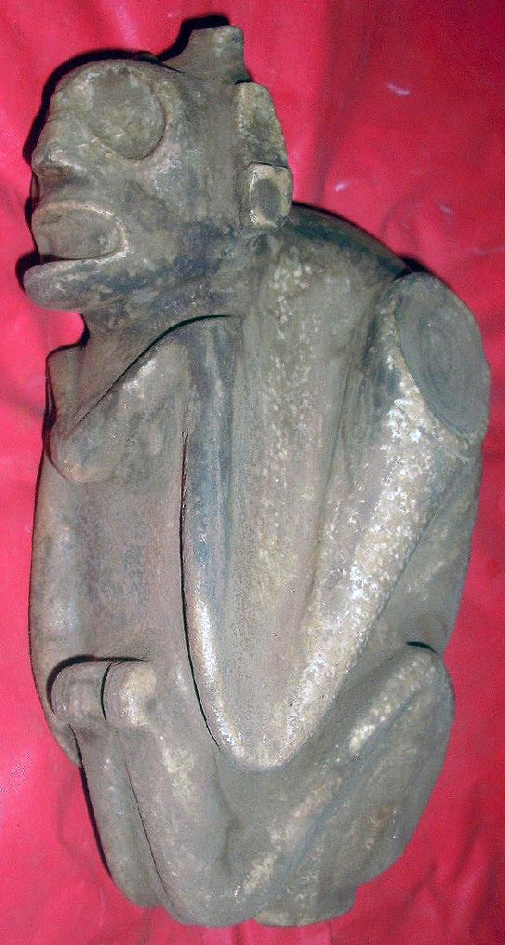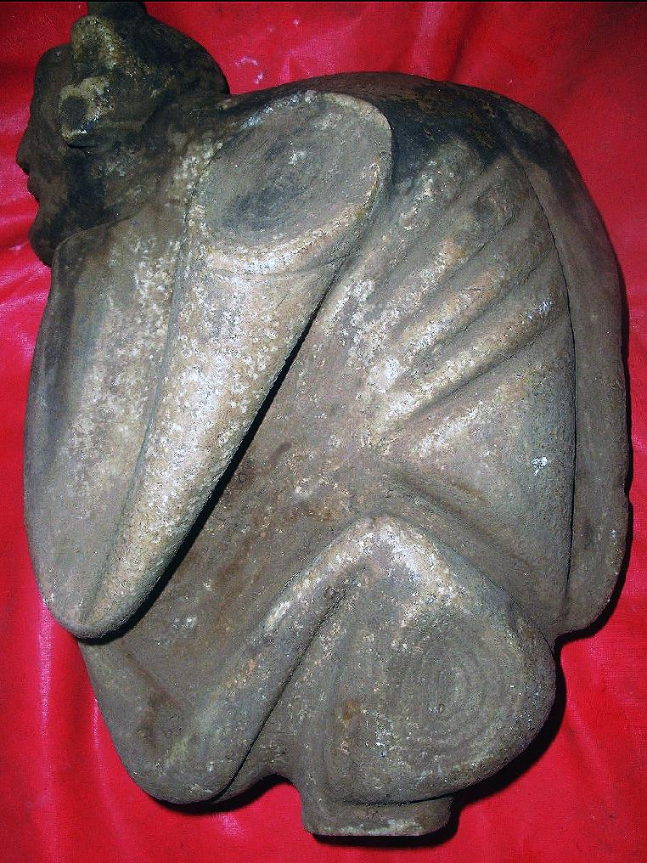

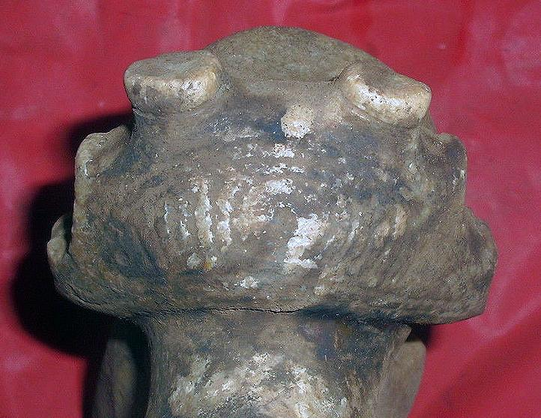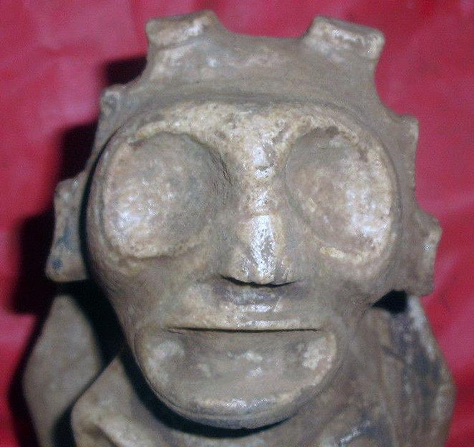

Case No.: 18

**Accession No.**

**Formal Label:** AM,C-Taino-Cemi-Opiyel Guobiran-Andesite-1000 CE

**Display Description:**

This *cemí* of Opiyelguobiran has limbs like that of a dog, but the head of an anthropomorphic animal with lately fallen antlers. It is clearly a composite anthropomorphic animal. With its clearly showing rib cage wide open eyes it suggests a spirit of a dead shaman in the process of changing into an animal familiar.

“They say a certain *cemí*, *Opiyel Guobiran*, had four feet like a canine and is [made] of wood, and that often he comes out of his house at night and enters the forests, They go there to seek him and bring him back to the house. They bind him with cords but he returns to the forests” (Pané, *Relación* XXII). The need of this cemi to return to the forest is clear: it is his duty to act as a guide for the dead on their journey to the next world:

**LC Classification:**

**Date or Time Horizon:**

**Geographical Area:**

**Map:**

**GPS coordinates:**

**Cultural Affiliation:**

**Media:**

**Dimensions:**

**Weight:**

**Condition:**

**Provenance:**

**Discussion:**

In Mexican mythology a dog swims across the Chignaguapan carrying the deceased on its back, and for that reason a golden-colored dog (colored like the sun) was interred with the body and accompanied the dead person, as Xolotl accompanied the sun during its underworld journey. In the Mayan codices, the dog is a symbol of the solar fire or ray; that is, the equivalent of Hun-Ahpú’s blowgun, the Mayan spirit of Energy and Life. Notice that this sculpture portrays the image of the spirit being as hunched over as ready to carry the dead on its back.

**References:**

Pané, *Relación* XXII